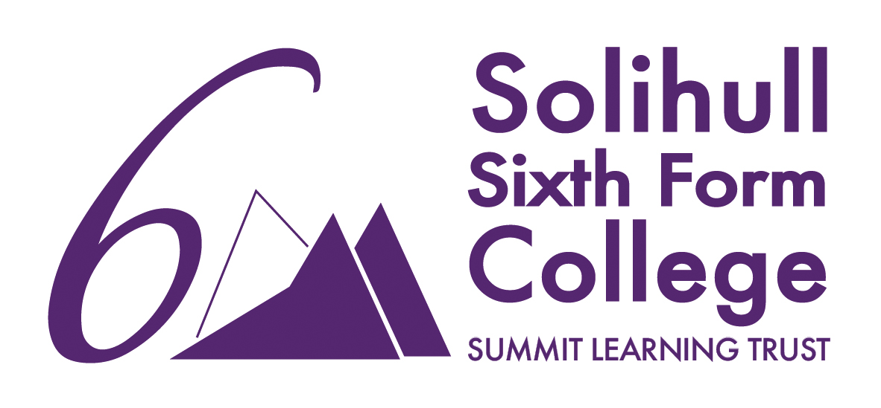
 Academic Misconduct Policy

Approved by: | SSFC LGB | Date: July 2026
Last reviewed on: | July 2026
Next review due by: | Subject to changes in College Policy
Monitoring & Review | To be monitored by SSFC LGB
Links | Exams Policies
Staff responsible | Oona Stone

Contents

- Introduction
- Prohibited Actions
- Consequences of Plagiarism
- Prevent Academic Misconduct and Plagiarism

A Introduction

A.1 Academic misconduct is any action which gains or attempts to gain an unfair academic advantage. This includes plagiarism, collusion (secretly agreeing with others to cheat or deceive) or cheating.

A2 Plagiarism is the act of presenting someone else's work, ideas, or words as your own without proper attribution or acknowledgment. This includes, but is not limited to, copying
text from a source without citation, paraphrasing without giving credit, and using someone else's ideas or intellectual property without permission or acknowledgment.

B Prohibited Actions

B.1 The following actions are strictly prohibited and will be considered as acts of academic misconduct or plagiarism:
- Submitting work that has been entirely or partially copied from another source without proper citation.
- Paraphrasing or summarizing someone else's work without acknowledging the original source.
- Using direct quotes from a source without appropriate citation marks and reference.
- Presenting another person's ideas, research, or intellectual property as one's own.
- Collaborating with others and submitting individual work without proper attribution to others.
- Using an attractive phrase or sentence you have found somewhere else.
- Downloading or copying pictures, photographs, or diagrams without acknowledging your sources.
- Submitting work with intentionally incomplete or misleading references.
- Cheating, that is, acting unfairly or dishonestly to gain an advantage.
- Tampering with the work of other students; this could include destroying or altering their work.
- Infringing in any way the regulations of the Examination Boards.

B.2 Plagiarism also includes the misuse of AI software. The range of AI tools and their capabilities is expanding quickly, and there are limitations to their use such as producing inaccurate or inappropriate content.
Examples of AI misuse include, but are not limited to, the following:
- Copying or paraphrasing whole responses or sections of AI-generated content so that the work is no longer the students own. This includes generation of video content.
- Failing to acknowledge use of AI tools when they have been used as a source of information.
B.3 Further guidance on AI use in assessments can be found in the JCQ document ‘AI Use in Assessments: Protecting the Integrity of Qualifications’.

C Consequences of Plagiarism
C.1 Plagiarism is a serious offence that undermines academic integrity, professional ethics, and personal credibility. The consequences of committing plagiarism may include one or more of the following, depending on the severity and frequency of the offence:
- The teacher will report the plagiarism to the Curriculum Leader for that subject area who will investigate. If required, the Curriculum Leader will meet with the student.
- The student will receive a ‘negative behaviour incident’ on Arbor by the assessor/teacher.
- The student will be asked to alter and resubmit the work that relates to the work that has been plagiarised.
- Notes of any meetings or actions taken will be recorded as a pastoral note on Arbor.

C2 Students who lend their work for others to plagiarise will be regarded as much in breach of the plagiarism policy as those who commit plagiarism and will have the same actions taken against them.
C3 Any student who is found to breach the plagiarism policy for a second time or at any other point during the course will have their work ‘frozen’ preventing any action to alter or resubmit any work. This will be reported to a Senior Leader who will investigate and appropriate actions put in place. The Senior Leader will report to the Principal.
C4 In cases deemed to be serious, the student will be required to meet with a senior leader so that steps may be taken to inform the examining body where appropriate, in line with their procedures. This may result in a zero mark being awarded for this course and other courses studied.
D Preventing Academic Misconduct and Plagiarism
D1 To prevent plagiarism and promote academic integrity, students will be shown how to prevent incidents of plagiarism prior to completion of any work. This will include:
- Education and awareness: Educate students about academic misconduct and plagiarism, its consequences, and how to properly attribute sources.
- Citation and referencing: Provide clear guidelines on how to cite and reference sources in accordance with recognized citation styles.
- Promote critical thinking, creativity, and independent thought to foster original work.

D2 Teaching staff will use plagiarism detection software like Turnitin to identify potential instances of plagiarism in submitted work.
D3 All students will read and sign to say they accept and understand the Academic Misconduct policy for students. Records will be kept with the Curriculum Leader.

 | ACADEMIC MISCONDUCT POLICY FOR STUDENTS | 

During your studies at college, you will produce work for assessment. This may be for internal purposes or form part of the assessment on your course and contribute towards your final grade. It is important the work you submit is your own work and anybody else’s work is correctly acknowledged using appropriate reference systems.

Academic misconduct is any action which gains or attempts to gain an unfair academic advantage. This includes plagiarism, collusion (secretly agreeing with others to cheat or deceive) or cheating.
Plagiarism is the act of presenting someone else's work, ideas, or words as your own without proper attribution or acknowledgment. This includes, but is not limited to, copying and pasting text from a source without citation, paraphrasing without giving credit, and using someone else's ideas or intellectual property without permission or acknowledgment.

It is important you understand exactly what help and guidance you are allowed – and are not allowed – so that you do not, perhaps without meaning to, submit a piece of work that does not comply with the guidelines.

The college’s Academic Misconduct Policy, which is set out below explains this to you.

The following are considered dishonest and therefore unacceptable within your college work:

- Submitting work that has been entirely or partially copied from another source without proper citation.
- Paraphrasing or summarizing someone else's work without acknowledging the original source.
- Using direct quotes from a source without appropriate citation marks and reference.
- Presenting another person's ideas, research, or intellectual property as one's own.
- Collaborating with others and submitting individual work without proper attribution to others.
- Using an attractive phrase or sentence you have found somewhere else
- Downloading or copying pictures, photographs, or diagrams without acknowledging your sources.
- Submitting work with intentionally incomplete or misleading references.
- Cheating, that is, acting unfairly or dishonestly to gain an advantage.
- Tampering with the work of other students; this could include destroying or altering their work.
- Infringing in any way the regulations of the Examination Boards.
Plagiarism also includes the misuse of AI software. The range of AI tools and their capabilities is expanding quickly, and there are limitations to their use such as producing inaccurate or inappropriate content.

Examples of AI misuse include, but are not limited to, the following:
- Copying or paraphrasing whole responses or sections of AI-generated content so that the work is no longer the students own. This includes generation of video content.
- Failing to acknowledge use of AI tools when they have been used as a source of information.
If you are suspected or discovered to have done any of the things shown in the list above, the college will investigate and take appropriate action.

What is expected of you whilst you are at college?
- You will hand in your own original work for assessment
- You will acknowledge when you have used someone else’s work and where you found the information using appropriate reference conventions e.g. Harvard referencing system.
- When you have used other sources of information, your work will include a bibliography.
- You will not use another student’s work and submit it as your own work.
- You will not allow another student to use or copy your work with the intention to pass it off as their own work.
- You will not tamper or alter the work produced by another student.
- When requested, you will submit your work through ‘Turnitin’. This is an anti-plagiarism software that checks your work against other student’s work, websites, journals, magazines, or books.

All cases of suspected academic misconduct will be investigated by the college. If proved, the college will use appropriate disciplinary procedures depending on the seriousness and frequency of misconduct. This can go up to and include achieving zero marks for an assessment, including those that contribute towards your final grade. If you are suspected to have plagiarised your work, your teacher may ask you to complete further work to feel confident it is your work.

I have read and understood what constitutes ‘Academic Misconduct’ and the expectations that are made of me whilst I am a student at Solihull Sixth Form College. I agree to uphold these expectations and I am fully aware of the consequences if I am found to have breached this policy.

Student name - ……………………………………………

Student S number - ………………………………

Student signature - …………………………………
Date - …………………………………

